Unity – Tower Defence

In this tutorial we will create a simple Tower Defence game using waypoints to guide the enemy along a pre-set path. For the defence a basic turret will be created that will track enemy within a given range and shoot constantly until the enemy is destroyed or out with the given range of the turret.

# Unity Version 2019.2.5f1

# Setting up the Project

1. Use unity hub or open Unity 2019.2.5f1 directly.
2. Click the **New** button to create a new project.
3. Choose the 3D template.
4. Name the project **TowerDefence**. (NOTE there are no spaces)
5. Make sure you have your projects Location set your own personal unity projects folder. (i.e. Desktop/YOURNAME/Unity Projects/ )
6. Click the **Create** button.
7. Save the current scene with ‘*Ctrl + S’* or ‘*File > Save’*. Rename the **SampleScene** in the ‘Scenes’ folder and rename it **Level1**.
8. A prompt informing of changes to open scene will appear, left-click the **Reload** button to reload the scene with the updated name.

# Setting up GitHub Repository

1. Open GitHub Desktop.
2. Use keyboard shortcut **CTRL + N** to create a new repository.
3. Name the project the exact same as your unity project **TowerDefence**.
4. Add a small description of your game, (i.e. Tower Defence game developed with Unity)
5. Set local path to YOUR **Unity Projects** folder. (i.e. Desktop/YOURNAME/**Unity Projects**) **ACTUAL UNITY PROJECTS FOLDER, NOT THE PROJECTS FOLDER WITHIN UNITY PROJECTS
6. Set **Git ignore** to **Unity** template, keep License at **None**.
7. Left-click the **Create Repository** button. (this creates the local repository on your computer)
8. Left-click the **Publish Repository** button.
9. In the window that appears check details are correct and Left-click the **Publish Repository** button. (this sends your repository to be created and stored in the GitHub cloud)

# Preparing the Scene

## Creating the Terrain

We will create a terrain object to act as the ground for the scene.

1. Make sure nothing is selected in the **Hierarchy** window, right-click in a blank space within this window. Then select **3D Object>Terrain** from the context menu that appears.
2. Now with the terrain object selected in the **Hierarchy** window, go to the **Inspector** window and change the name of the terrain to **Ground.**
3. With the **Ground** object still selected, browse to the **Inspector** window and find the **Terrain** component. We are goin to edit the size of the terrain as the default size is too large for our purpose. On this component you will find the terrain editing toolbar, when the mouse hovers over this tool bar a tooltip will show each sections name. The cog wheel section highlighted below is called **Terrain Settings**. Left click this option now. 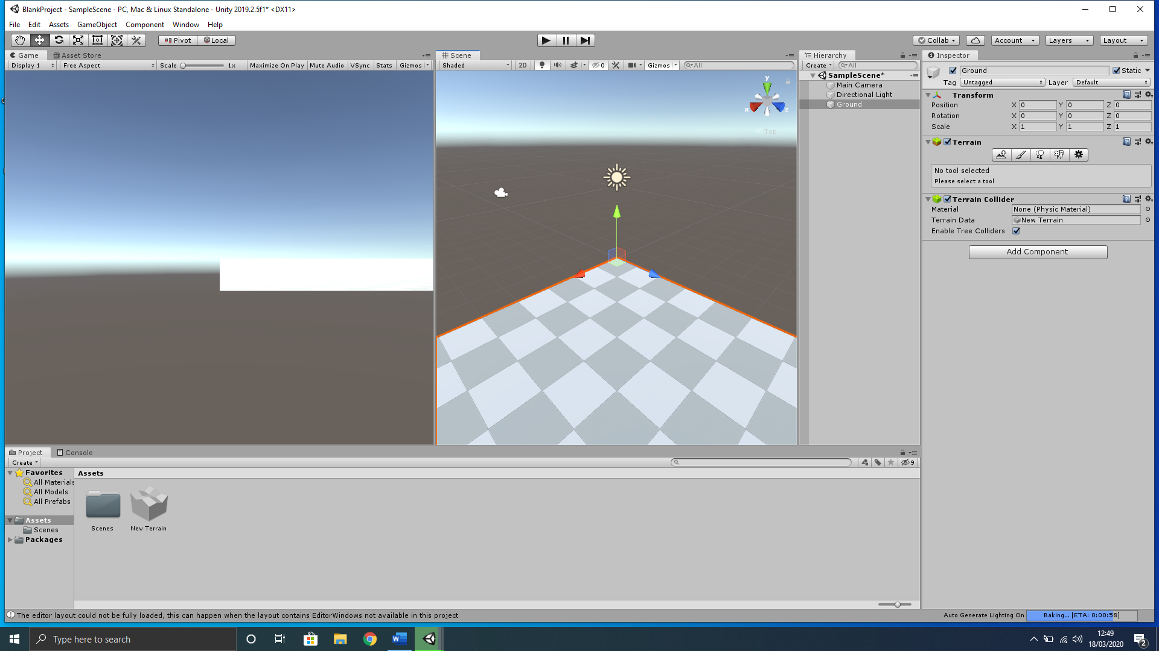
4. Scroll down through the new settings that appear until you reach the **Mesh Resolution (On Terrain Data)** section. In **Terrain width**  and **Terrain Length**,change both values to **100** and leave the other sections at the default settings**.**

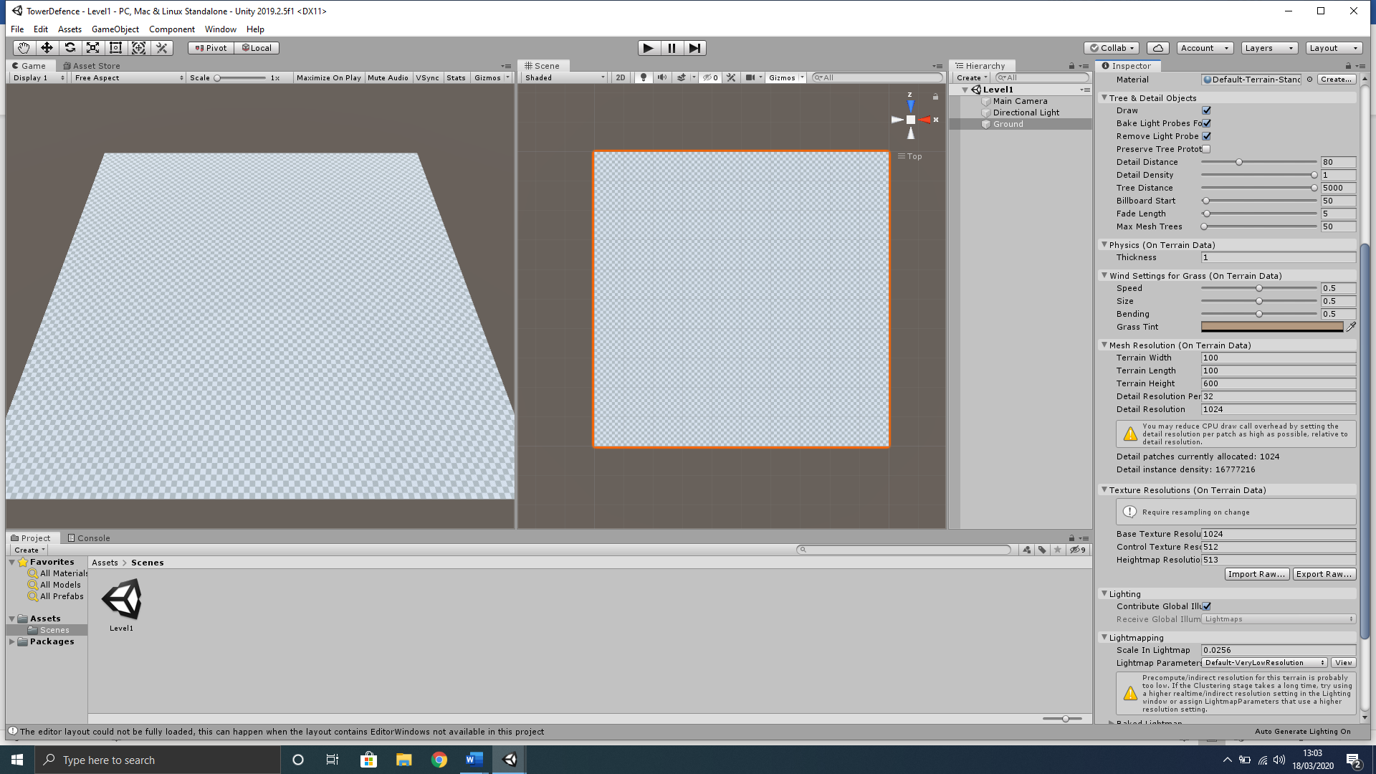

1. At this point you may not have noticed any changes; however, we have changed the terrain size. To help us see the full terrain, better position objects and edit, we should change our **Scene** view to a birds-eye view. This can easily be achieved by using the camera transform component in this **Scene** window. Left-click the **Y** axis (green cone) highlighted below.

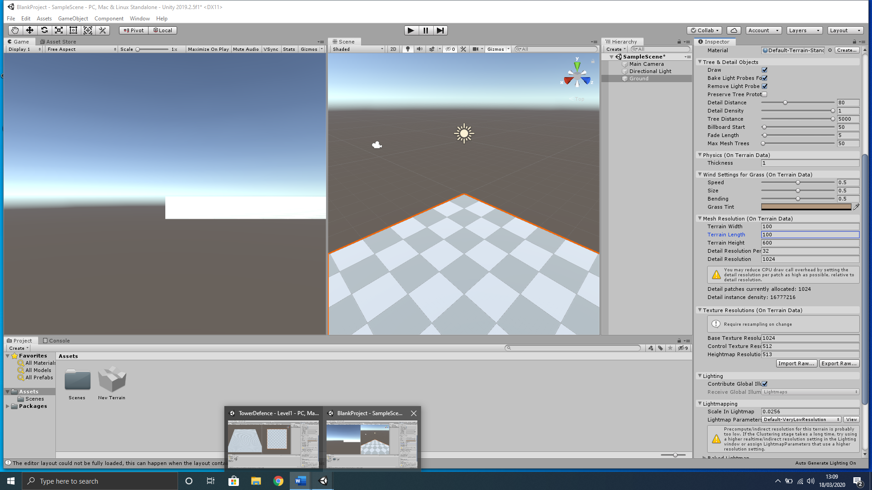

1. You will notice that we still cannot see the full terrain. Use the pan selection (left-click and hold the scroll wheel) and the zoom tool (scroll wheel) within the **Scene** window to position the full terrain within the view like below;

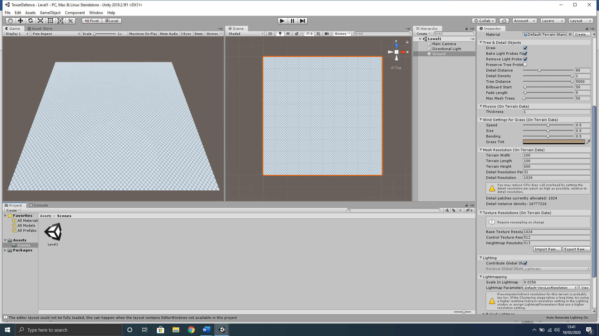

## Static Camera Position

We will set up the default position for the camera to display the game to the user in the **Game** view window.

1. In the **Hierarchy** select the **Main Camera** object.
2. Now with this **Main Camera** object selected in the **Inspector** set the **Transform** component to the settings below;

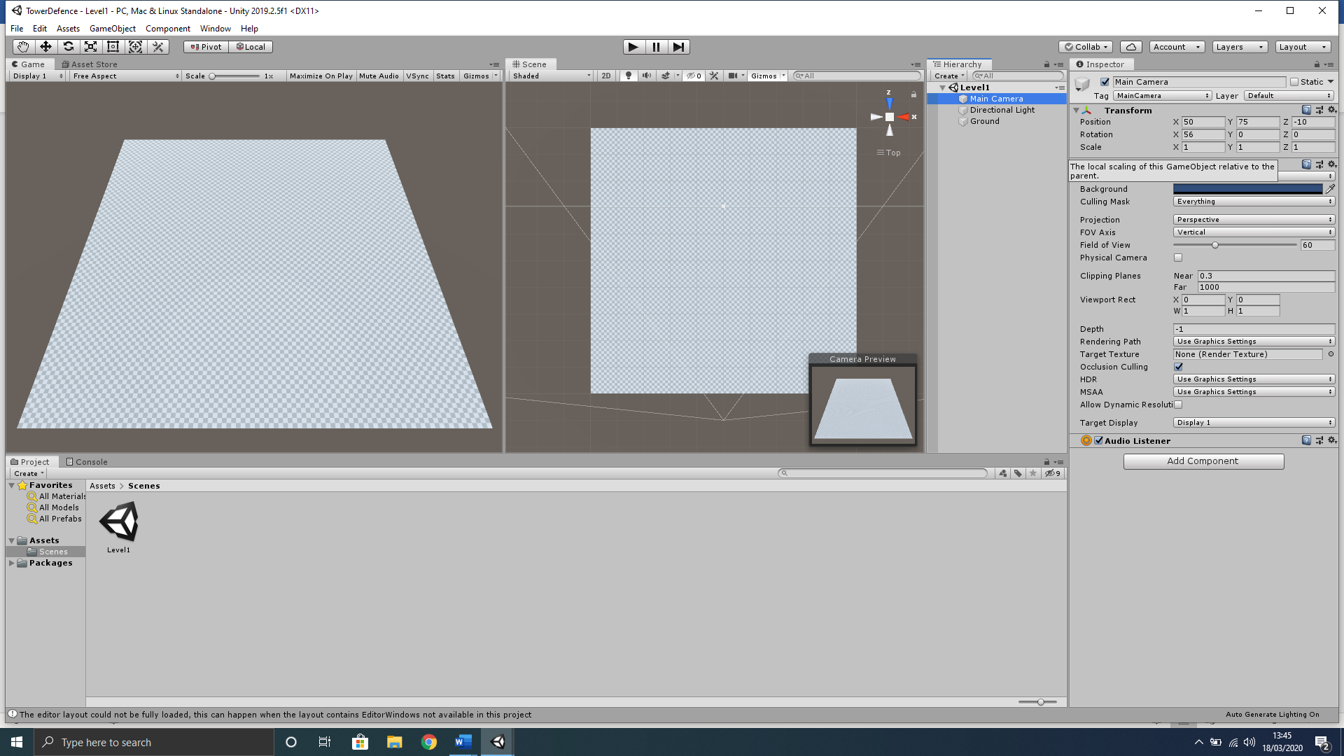

Your scene has now been setup to make it easier to view and edit our game. Remember how you have learned in class that Unity window layouts can be arranged to suit your own workflow, however, we discussed for our development purposes the layout we use to display both the **Game** view window and **Scene** view window side by side, with your **Hierarchy** window next to your **Inspector** window to better connect components. Your overall Unity scene layout should look like below;



# Creating the Path

We will create a basic path for our enemies to follow with a Start and End location. This path will also be laid out with waypoints for the enemy to reach sequentially. We also create a script to accept these waypoints regardless of the amount, however, it is advised at this early stage to keep the waypoint count low and design a simple path until we have our functionality fully tested and working.

## Start Location

Here we will create a simple 3D cube to represent the start location for the enemy troops as a basic prototype object, this can be later to make a more graphically fitting object like a building, automobile or dropship.

1. With nothing selected in the **Hierarchy** window, right-click in an empty space and select **3D Object>Cube** from the context menu that appears.
2. Rename this cube in the **Inspector** to **Start**.
3. Reset the **Transform** component by right-clicking on the word “Transform” and select Reset from the context menu that appears.
4. We will now position the **Start** object up in the top left of our **Ground** object and increase the size slightly using the **Start** objects Transform component. Set it like below;

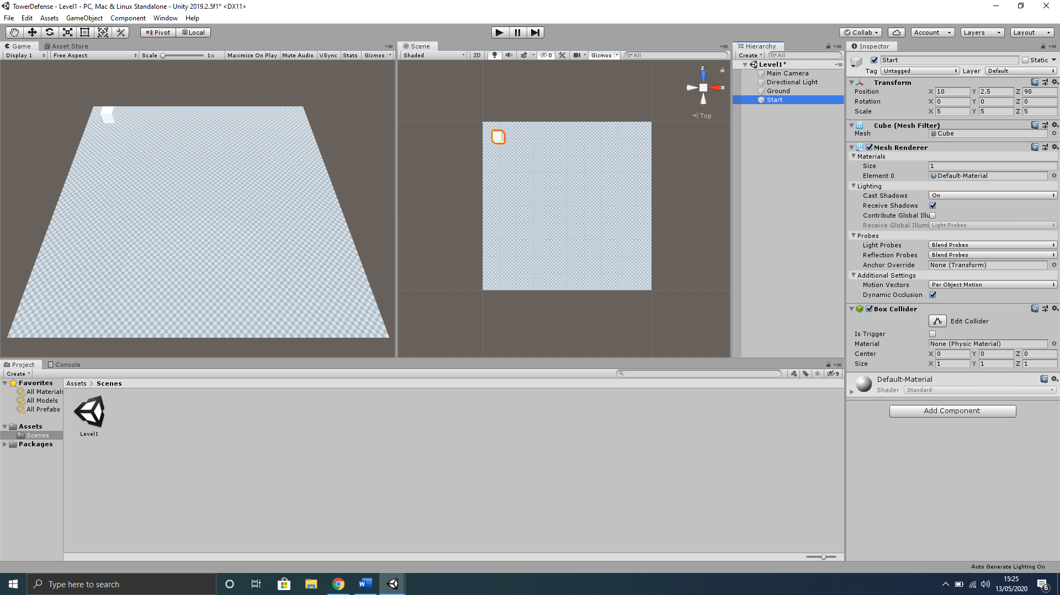

## End Location

1. With nothing selected in the **Hierarchy** window, right-click in an empty space and select **3D Object>Cube** from the context menu that appears.
2. Rename this cube in the **Inspector** to **End**.
3. Reset the **Transform** component by right-clicking on the word “Transform” and select Reset from the context menu that appears.
4. We will now position the **End** object up in the top left of our **Ground** object and increase the size slightly using the **End** objects Transform component. Set it like below;

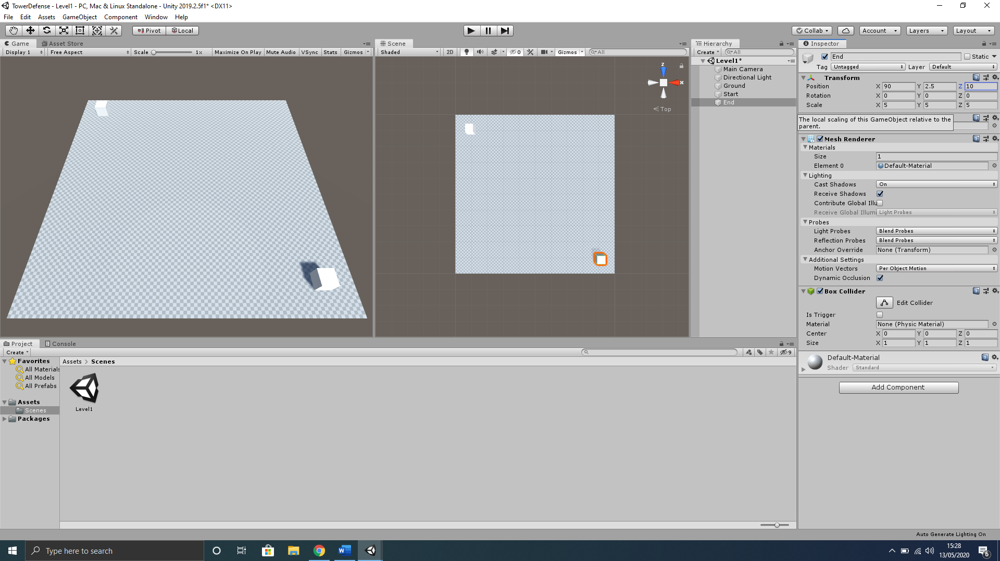

## Creating Start/End Materials

You will notice it is quite hard to distinguish the **Start** and **End** cube from the **Ground** terrain object, therefore, we will create a material for both the **Start** and **End** cube.

1. With nothing selected in the **Project** window, make sure you are in your **Assets** folder and right-click in an empty space and select **Create>Folder** from the context menu that appears.
2. Rename this folder to **Materials** and open this folder in the **Project** window.
3. Now with nothing selected right-click in an empty space and select **Create>Material** from the context menu that appears.
4. Rename this **Material** to **Start_Mat.**
5. With Start_Mat still selected go to the Inspector and under Main Maps section select the colour picker tool next to Albedo component and change to a bright Green colour like below;

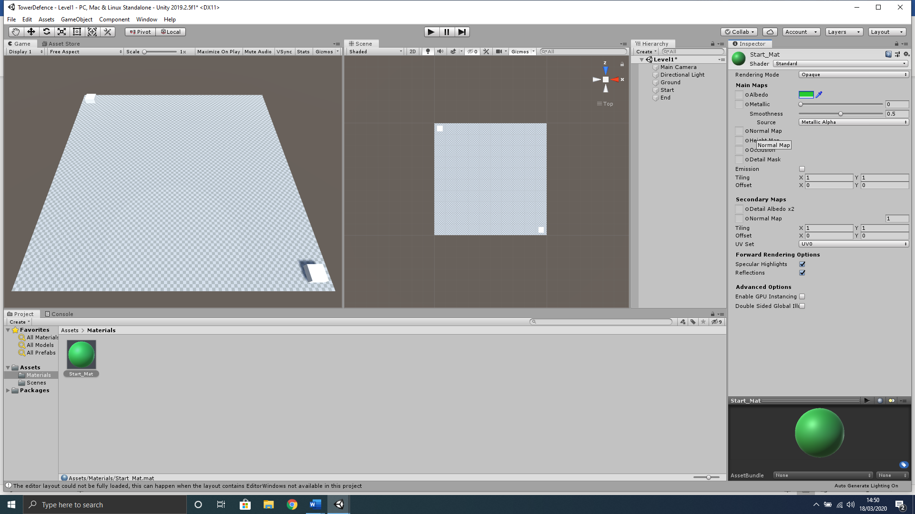

1. In the **Project** window make sure you are in **Assets>Materials** folder and left-click the **Start_Mat** material once to select and use keyboard shortcut **CTRL+D** to duplicate the material.
2. Rename this duplicated material to **End_Mat** and change the **Albedo** colour to **Red**.

## Assigning Start/End Materials

Now that we have created the materials for both the Start and End objects we must assign them to each corresponding object.

1. From the Project window left-click, hold and drag the **Start_Mat** onto the **Start** object in the **Hierarchy** window.
2. Again, from the Project window left-click, hold and drag the **End_Mat** onto the **End** object in the **Hierarchy** window.

## Creating a Waypoint

We will now create waypoints for the enemy objects to follow. These waypoints will be used by a script later as targets for each enemy object to travel to. As mentioned earlier we want to keep it simple for development with not too many waypoints.

1. With nothing selected in the **Hierarchy** window, use the keyboard shortcut **CTRL+Shift+N** to create a new empty object.
2. Rename this object to **Waypoint**.
3. Reset the **Transform.**
4. Now in the **Inspector** window to the left of where the objects name is, there is a dropdown menu we can use to change the display icon for the object;

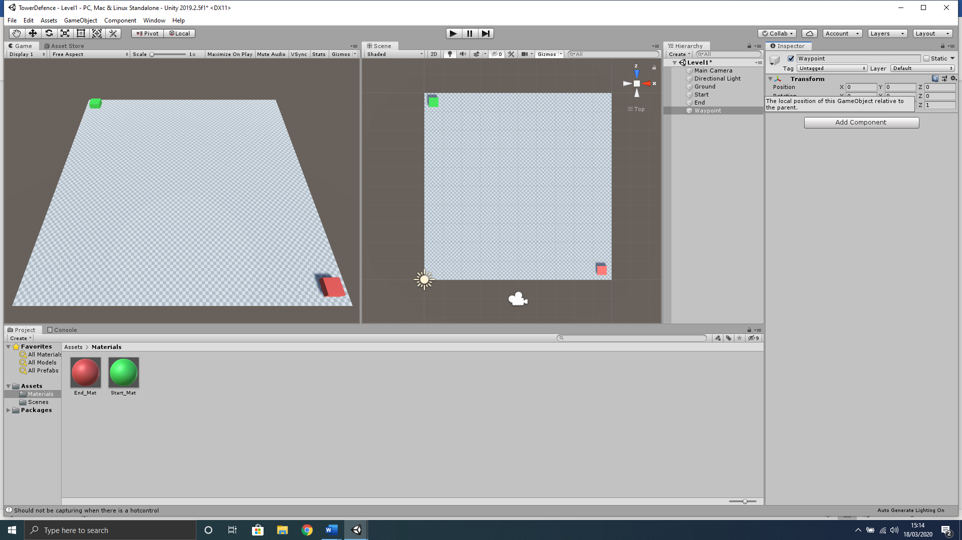

1. Change this to the **Yellow** Capsule icon;

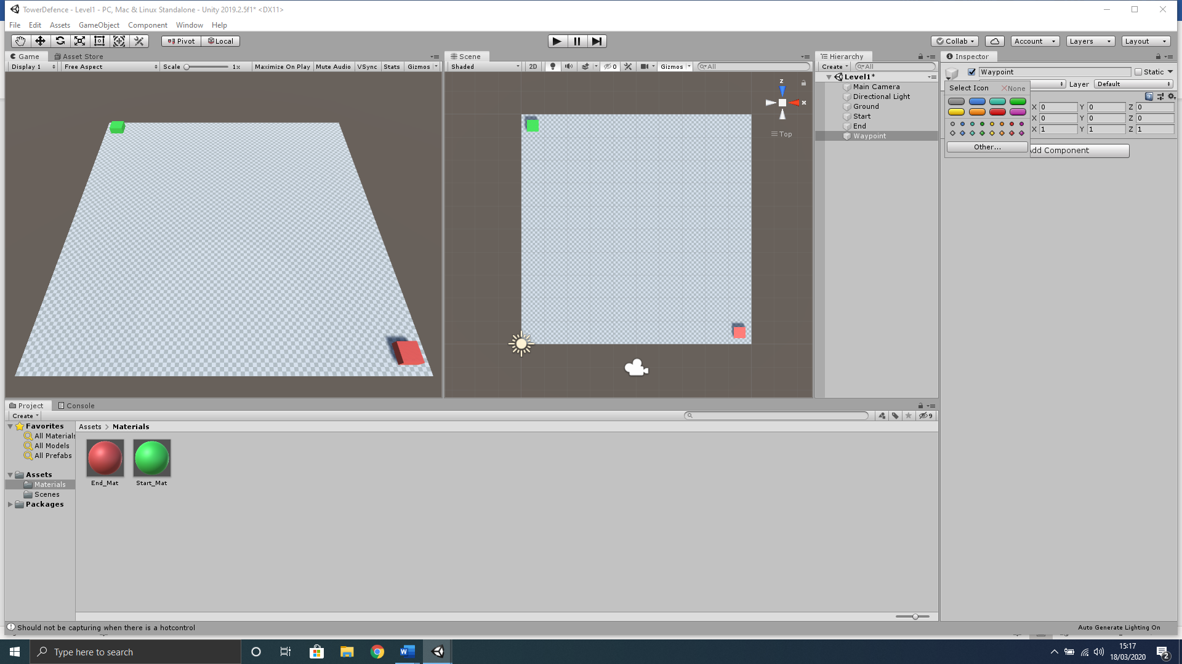

1. You may not be able to see this yet as the Icon size may still be set rather low. We can simply change this by clicking the Gizmos tab in the Scene window toolbar;
2. 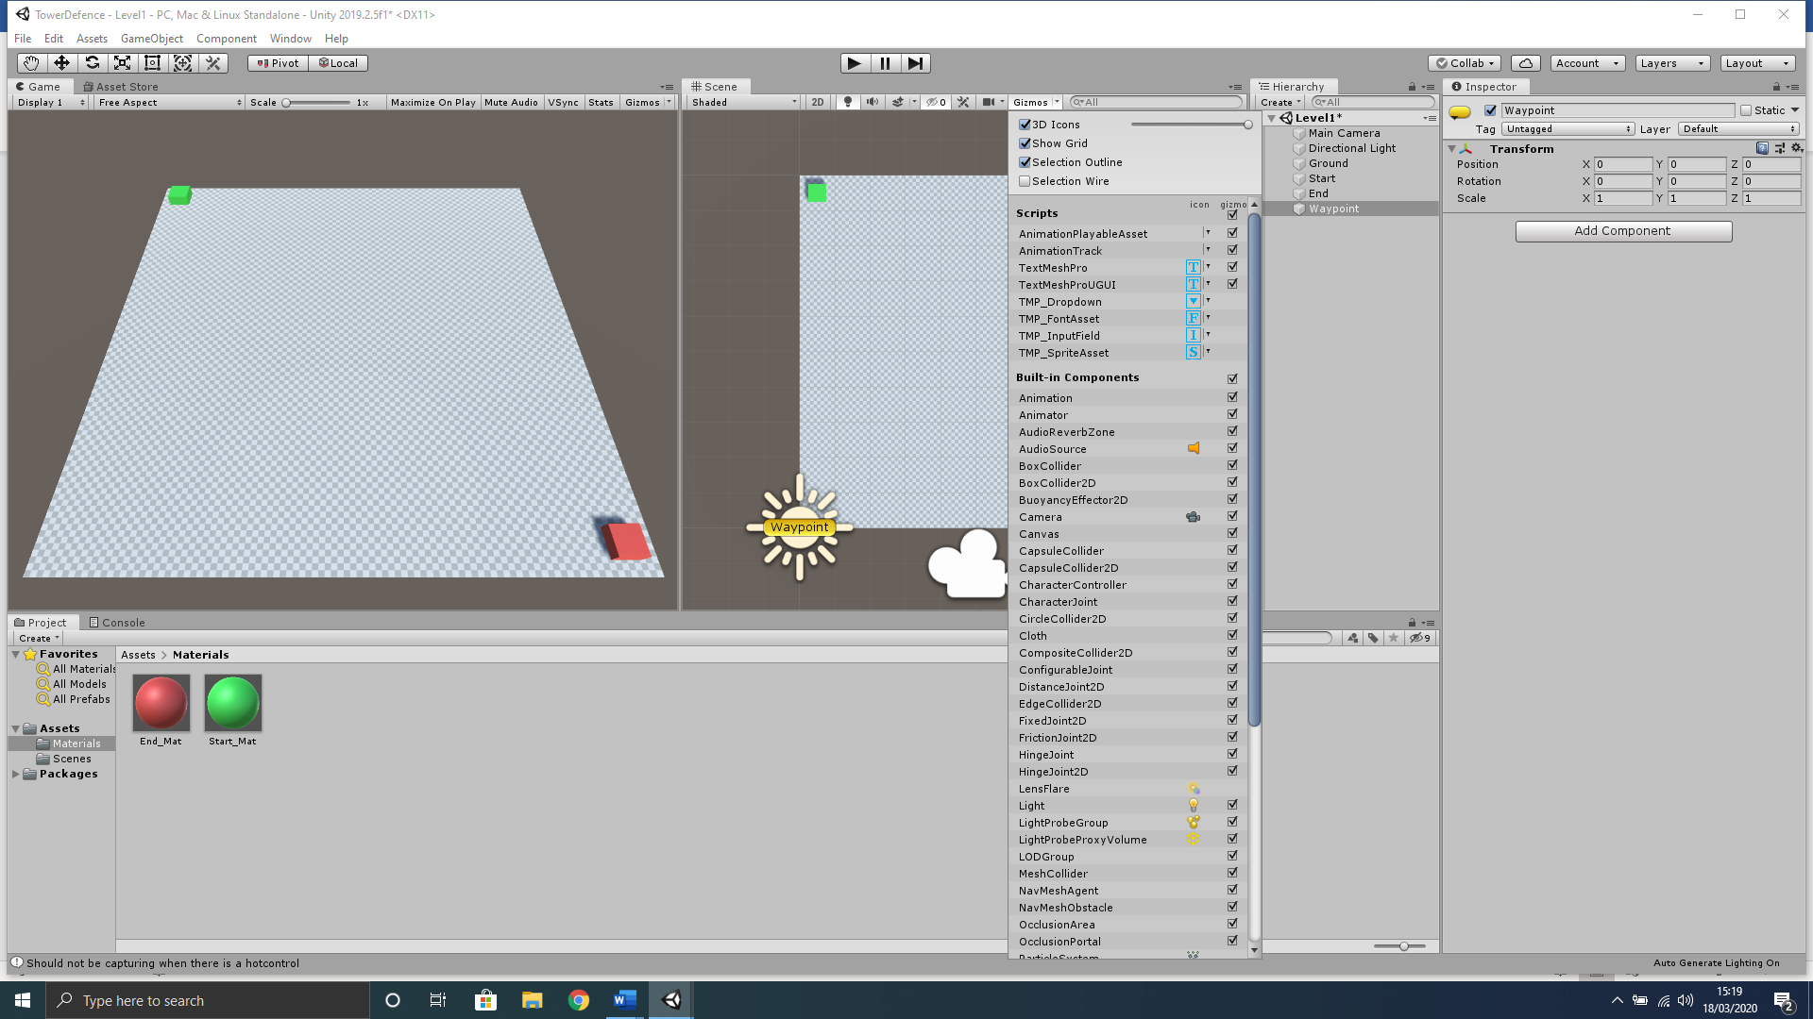
3. At the top of the context menu that appears, change the 3D Icons slider to maximum position;



You will notice all of the Icons within the Scene window have now been enlarged helping us see the waypoint icon better, however, the directional light icon is now in the way of selecting this object as its X/Y coordinates are similar. We can simply move this out of the way to save future issues.

1. In the **Hierarchy** window select the **Directional Light** object and change the Transform component like below to move it out of our way; 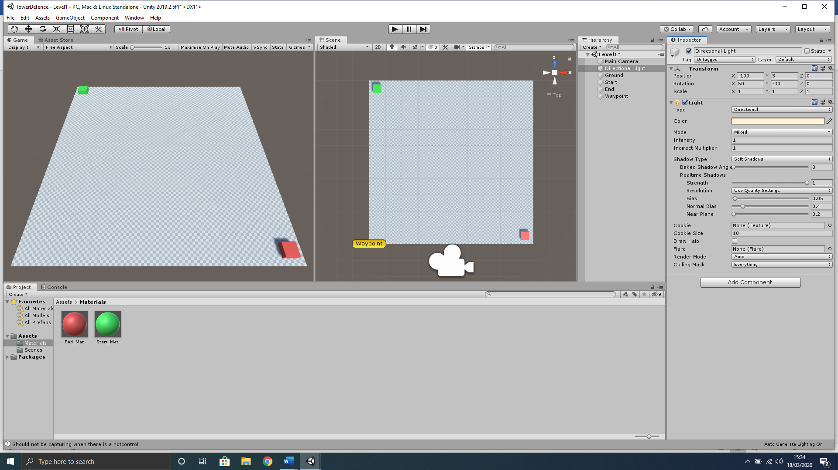
2. We can also position our newly created waypoint to the next location we would like our enemies to travel to from the start locaion. You can set this how you like, however, remember the enemy will travel in a straight line to this waypoint, so try not to make it overly complex to begin with and keep it rather close to your Start object;

## Duplicating Waypoints

Now that we have created and set up one waypoint it makes sense to simply duplicate this rather than setting all other waypoints individually. At this point in development we want to keep it simple so I would recommend no more that 6 waypoints in total with the end waypoint situated directly over the End object.

1. With the Waypoint object selected in the Hierarchy window, press the keyboard shortcut **CTRL+D** 5 times in a row to create your remaining 5 waypoints. (You will notice Unity automatically names these duplicated waypoints as Waypoint(1), Waypoint(2)… etc.)
2. Now position these waypoints sequentially creating an invisible path to the End object, with the End object containing the last waypoint object, like below;

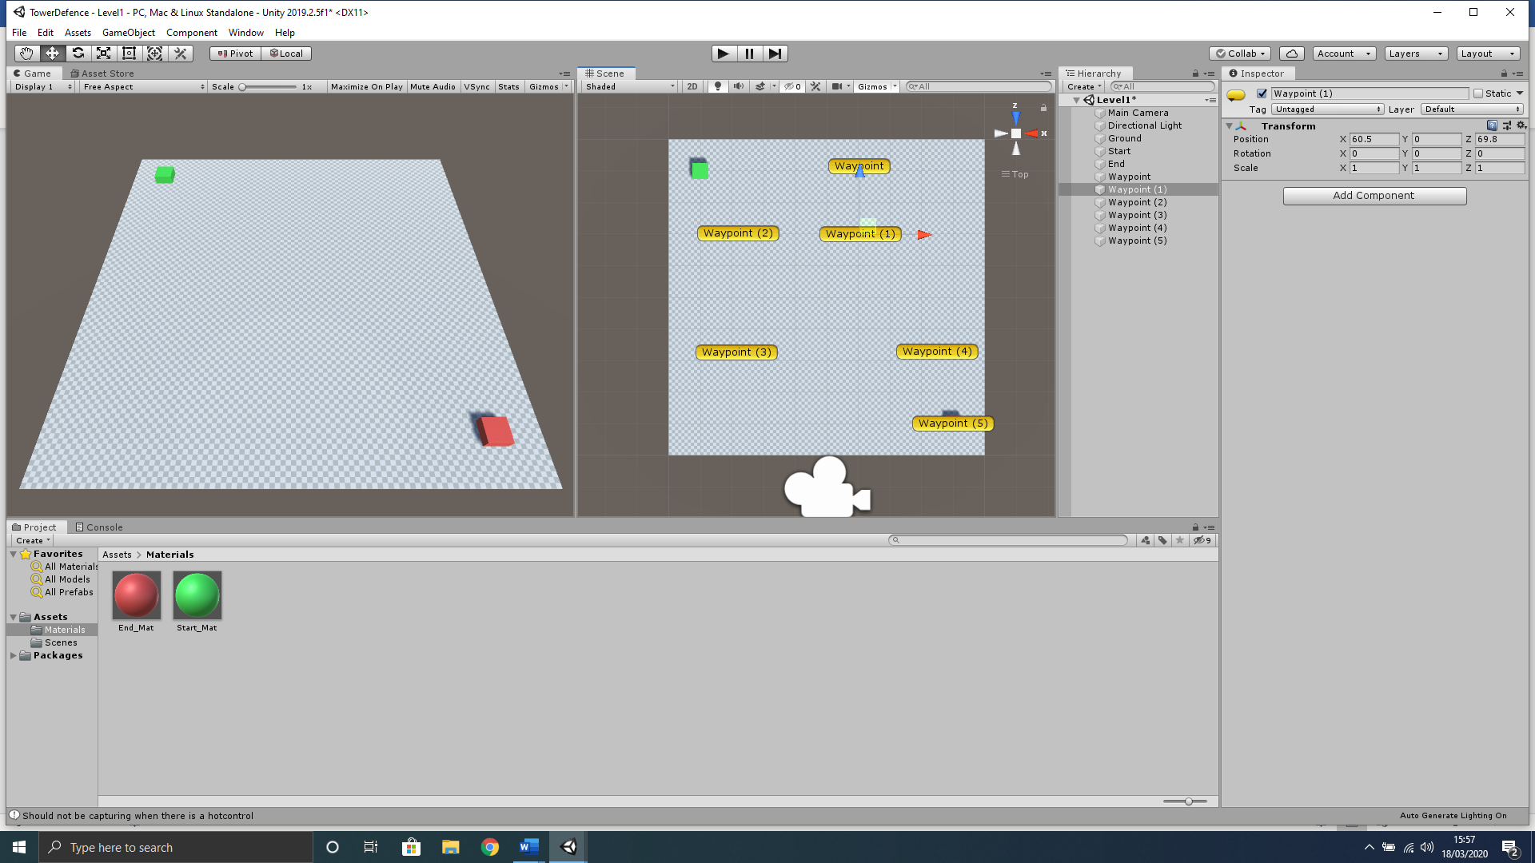

# Designing the Terrain

We can use the toolbar of the terrain object to raise lower and shape the Ground object. Using different brushes and textures design a simple ground for our terrain. The main ground can use the **brushes** to make hill/mountains and final path is created using the **Set Height** tool set to 1. Attempt to create a **Ground** object like below; 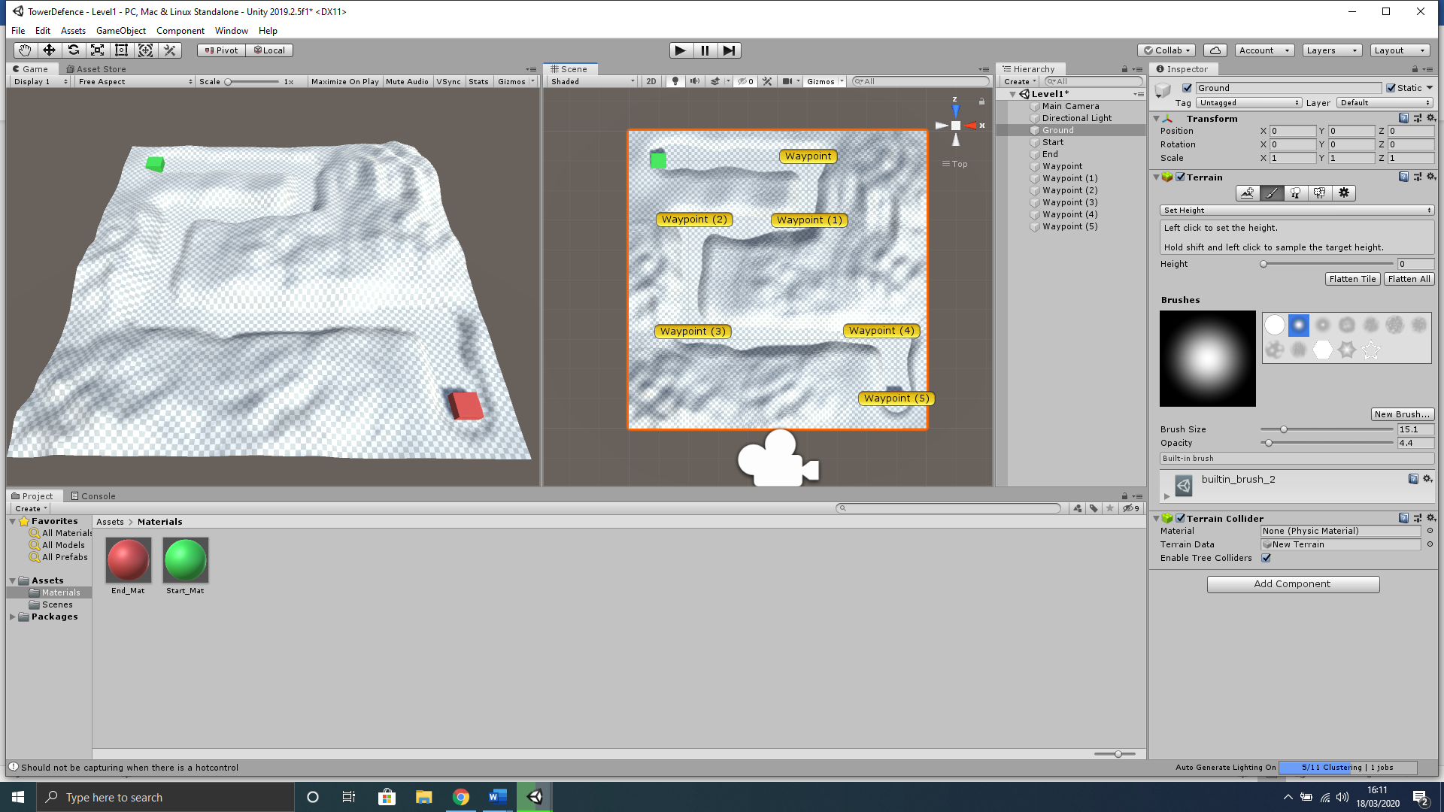

You will notice I haven’t really put much into the design at this point however you can by adding ground textures. As this is not a design class I will not show too much in the way of design and would recommend that you investigate how to use the new terrain tool for yourselves by Googling/Youtube Unity new terrain. (Note there has been a new terrain tool since 2018.3 and youtuber Sykoo has a nice tutorial that can help you get to grips with each part LINK = <https://www.youtube.com/watch?v=2Vvwjfp-hg8>) DO NOT ADD TREES OR ANY OTHER 3D OBJECTS FOR NOW.

# Waypoints Script

Now that we have our individual waypoints created we are going to create an empty object to contain all waypoints, which we can then attach a script to, giving us the ability to easily access and manipulate them using a static reference, as this will be able to be accessed from any other script.

1. With nothing selected in the **Hierarchy**, use the keyboard shortcut **Ctrl+Shift+N** to create a new empty object.
2. Rename this object **Waypoints**.
3. Now in the **Inspector, r**ight-click on the word **Transform** and then select **Reset.**
4. Now select all your waypoints in the **Heirarchy** and **left-click, hold and drag** them onto the **Waypoints** object as children.
5. Select **Waypoints** in the **Hierarchy** and set the transform in the **Inspector** like below; 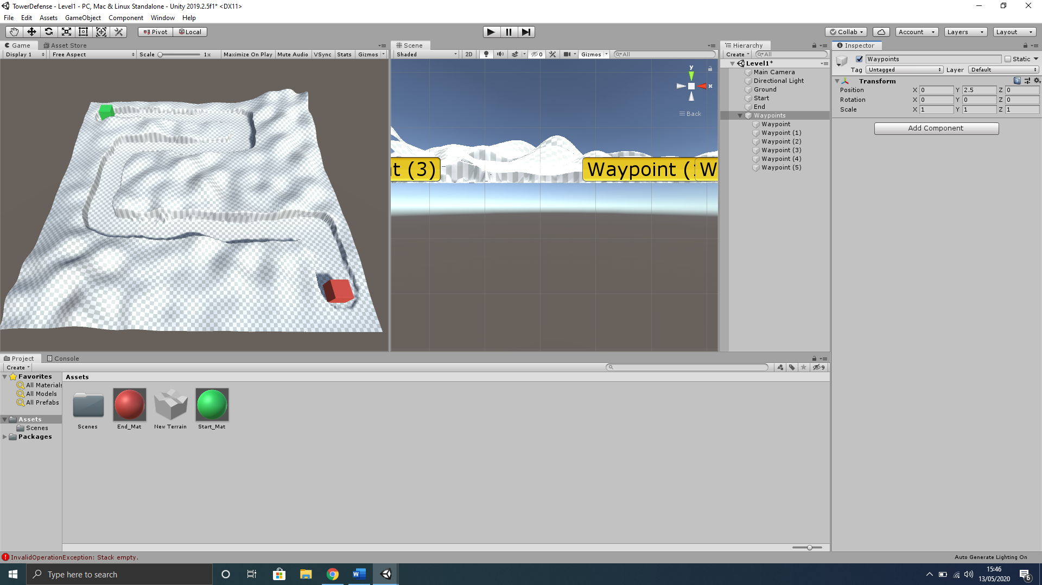
6. In the **Hierarchy** left click the **Waypoints** object and, in the Inspector, left click the **Add Component** button.
7. In the search box that appears type the name **WaypointsScript,** then left click the **New Script** option below that is highlighted in blue.
8. Double check you have named the script properly, then left-click the **Create and Add** button.
9. Now in the **Project** window select the **Assets** folder and double left-click the **WaypointsScript** to open in Visual Studio.
10. Amend your **WaypointsScript** to contain the code below;
11. using UnityEngine;
12. public class WaypointsScript : MonoBehaviour
13. {
14. // Create a public static array of waypoints that can be accessed anywhere
15. public static Transform[] points;
16. // Awake is called before the first frame update
17. void Awake()
18. {
19. // create array for all objects within the Waypoints object
20. points = new Transform[transform.childCount];
21. // iterate through the array
22. for (int i = 0; i < points.Length; i++)
23. {
24. // set each object found to the current location in the array
25. points[i] = transform.GetChild(i);
26. }
27. }
28. }

# Creating the Enemy

1. With nothing selected in the **Hierarchy** window, right-click in an empty space and select **3D Object>Sphere** from the context menu that appears.
2. Rename this sphere in the **Inspector** to **Enemy**.
3. In the **Inspector, r**ight-click on the word **Transform** and then select **Reset.**
4. Press the **W** key on the keyboard to enable the object transform tool.
5. In the **Inspector** set the **Enemy** object **Transform** component to the same **Transform>Position X** and **Z** of the **Start** object, and then set **Transform>Position Y** of the Enemy object height to **2.5.**
6. Also, within the **Transform** component of the **Enemy** object, set the **Scale** in **X, Y** and **Z** to **2.** The final transform should look like below.

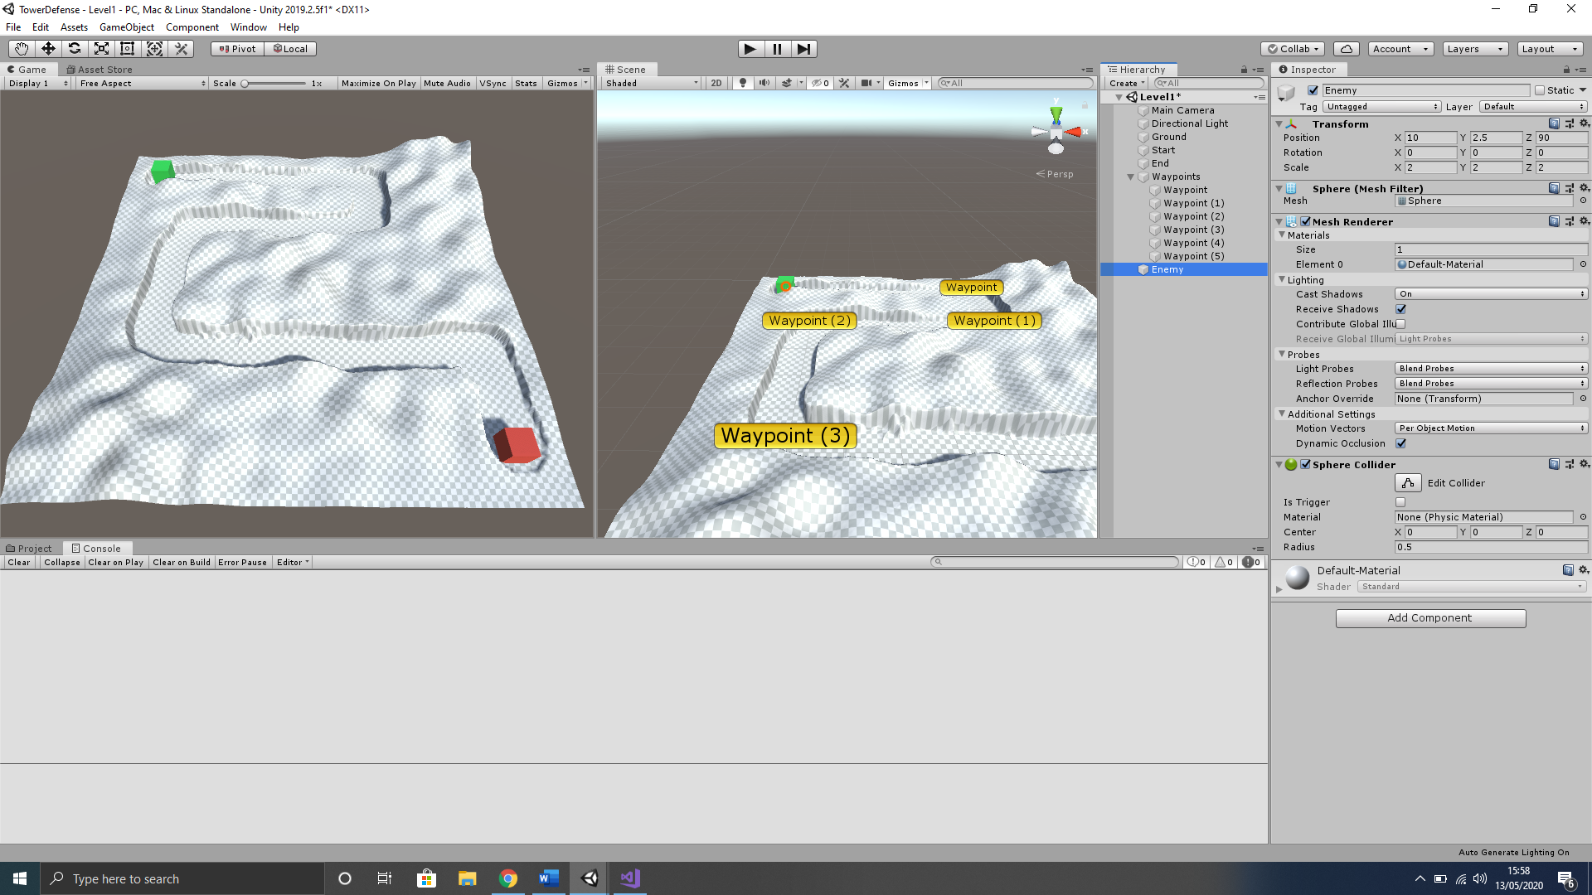

## Enemy Material

We will now create a new material named **Enemy_Mat** and set the **Albedo** colour to a **Light Blue,** then add it to our newly created **Enemy** object. (By now you should be able to create and apply a material to an object without complete guidance).

## Enemy Script

We will now create a script and add it to the enemy that will guide them through the waypoint path.

1. In the **Hierarchy** left click the **Enemy** object and, in the Inspector, left click the **Add Component** button.
2. In the search box that appears type the name **EnemyScript,** then left click the **New Script** option below that is highlighted in blue.
3. Double check you have named the script properly, then left-click the **Create and Add** button.
4. Now in the **Project** window select the **Assets** folder and double left-click the **EnemyScript** to open in Visual Studio.
5. Amend your **EnemyScript** to contain the code below;
6. using System.Collections;
7. using System.Collections.Generic;
8. using UnityEngine;
9. public class EnemyScript : MonoBehaviour
10. {
11. // set enemy speed
12. public float speed = 10f;
13. // Create a transform variable for target position
14. private Transform target;
15. // Set waypoint index variable
16. private int waypointIndex = 0;
17. void Start()
18. {
19. // set the target transform to public static Waypoints array
20. target = WaypointsScript.points[0];
21. }
22. void Update()
23. {
24. // get the direction to target location
25. Vector3 dir = target.position - transform.position;
26. // move to the target location
27. transform.Translate(dir.normalized * speed * Time.deltaTime, Space.World);
28. // When close to next waypoint get next target
29. if(Vector3.Distance(transform.position, target.position) <= 0.2f)
30. {
31. GetNextWaypoint();
32. }
33. }
34. void GetNextWaypoint()
35. {
36. if(waypointIndex >= WaypointsScript.points.Length - 1)
37. {
38. // destroy the gameobject at last waypoint
39. Destroy(gameObject);
40. // wait til game object is deleted before continuing
41. return;
42. }
43. // increment the waypoint index
44. waypointIndex++;
45. // set next target
46. target = WaypointsScript.points[waypointIndex];
47. }
48. }

## Create an Enemy Prefab

1. In your **Project** window, right-click on the **Assets** folder and select **Create>Folder** and name it **Prefabs.**
2. In **Hierarchy** window left-click, hold and drag the **Enemy** object down to the newly created **Prefabs** folder, to make an enemy prefab.
3. Now save your work and run the project to test.

# Create 3D Turrets from Primitives

In this section we will create three different turret guns from Unity’s primitive 3D models to build a prototype for our game. Different models to replace these protypes can be added at a later stage. I will show how to build one turret then you must use the same technique to create the remaining two turrets. Keep in mind that these turrets will be rather small on screen therefore finer details will not be seen.

1. With nothing selected in the **Hierarchy**, use the keyboard shortcut **Ctrl+Shift+N** to create a new empty object.
2. Rename this object **CannonTurret**.
3. Now in the **Inspector, r**ight-click on the word **Transform** and then select **Reset.**
4. Now in the **Hierarchy, r**ight-click on the **CannonTurret** object and then select **3D Object>Cube** from the context menu that appears. (NOTE!!! No need to reset transforms here as this cube should be attached as a child object of **CannonTurret**)
5. Rename this cube in the **Inspector** to **Base**.
6. To view your turret closer, make sure you have it selected in the **Hierarchy** and then hover your mouse over the **Scene** window, and press the **F** on your keyboard to zoom straight to the selected object.
7. In the **Scene** window, right-click, hold and drag the mouse to change the view to a perspective view of the cube. Your view should look similar where your terrain should be positioned behind the cube in the **Scene** view.

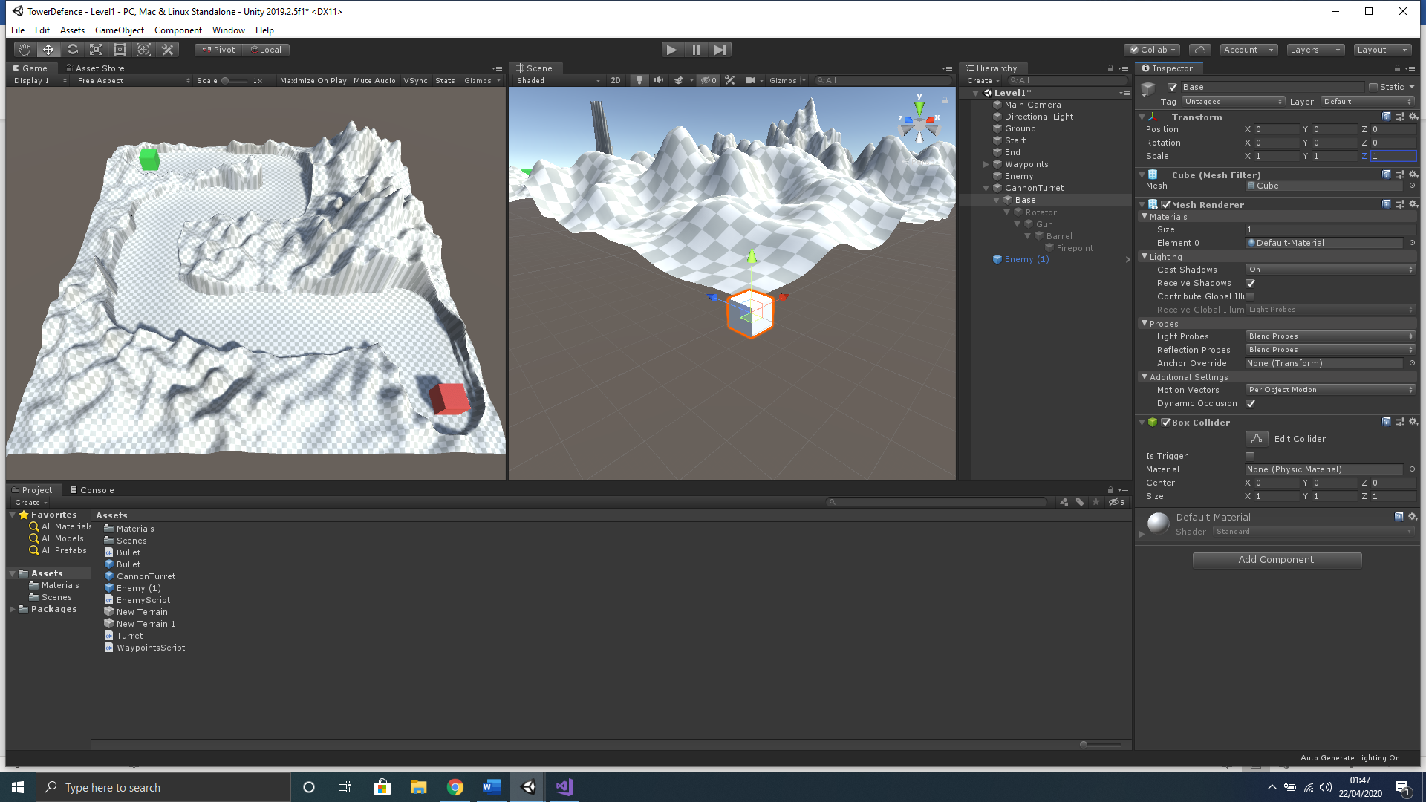

1. We will make the base a little wider by editing the **Transform** component in the **Inspector**, set both the **Scale** of **X** and **Scale** of **Z** to a value of **3;**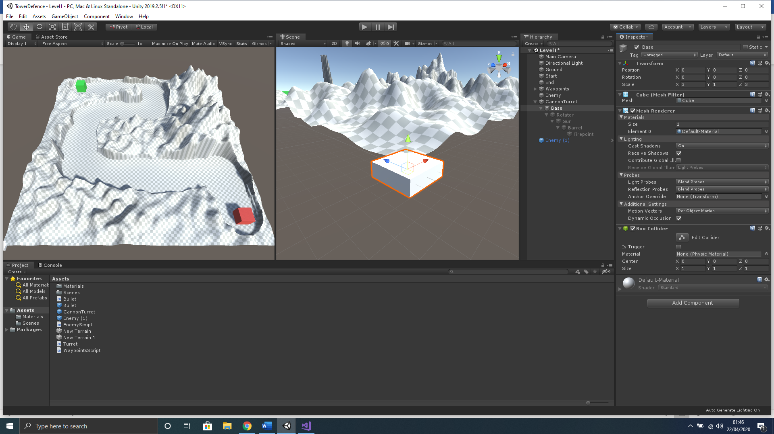
2. In the **Hierarchy, r**ight-click on the **Base** object and then select **3D Object>Cylinder** from the context menu that appears. (AGAIN NOTE!!! No need to reset transforms here as this cylinder should be attached as a child object of **Base**)
3. Rename this cylinder in the **Inspector** to **Rotator**.
4. The **Rotator** should be scaled down by **0.5** and slightly adjusted in height by **0.5**, set the transform like below;

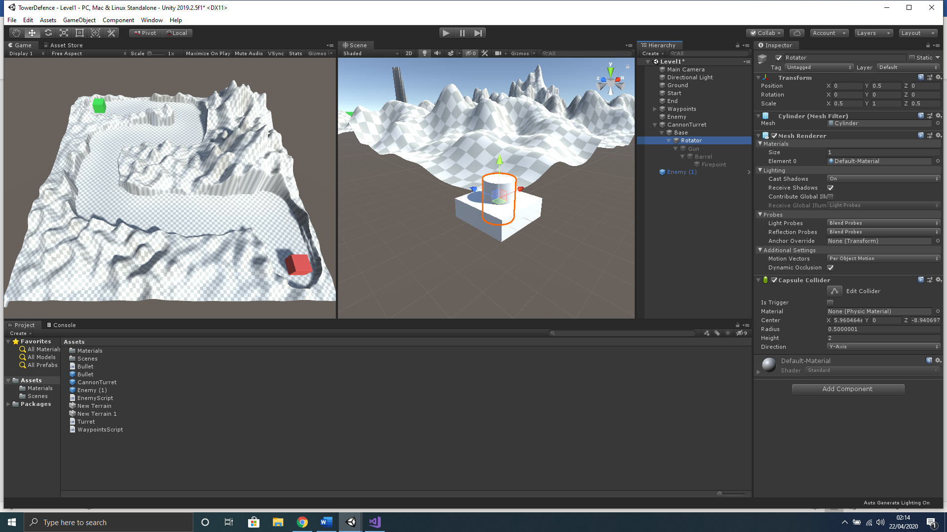

1. In the **Hierarchy, r**ight-click on the **Rotator** object and then select **3D Object> Cube** from the context menu that appears.
2. Rename this cylinder in the **Inspector** to **Gun**.
3. The **Gun** width should be scaled up **1.5** in the **X** and **Z**, alsoshould be adjusted in height by **1.5** on the **Y** position, set the transform like below;

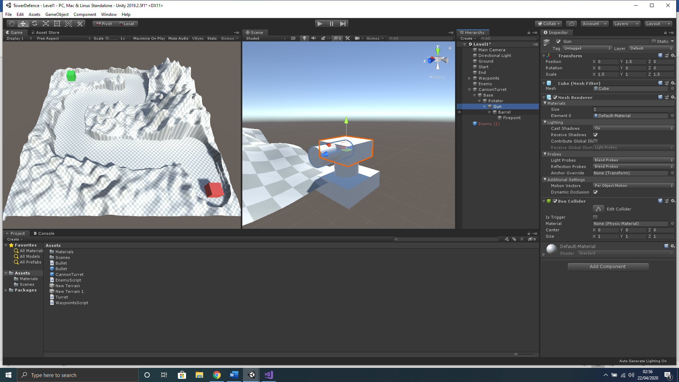

1. In the **Hierarchy, r**ight-click on the **Gun** object and then select **3D Object> Cylinder** from the context menu that appears.
2. Rename this cylinder in the **Inspector** to **Barrel**.
3. The **Barrel** width should be scaled down to **0.5** in the **X** and **Y**, rotated by **90** on **X** andshould be adjusted in height by **0.5** on the **Y** position, set the transform like below; 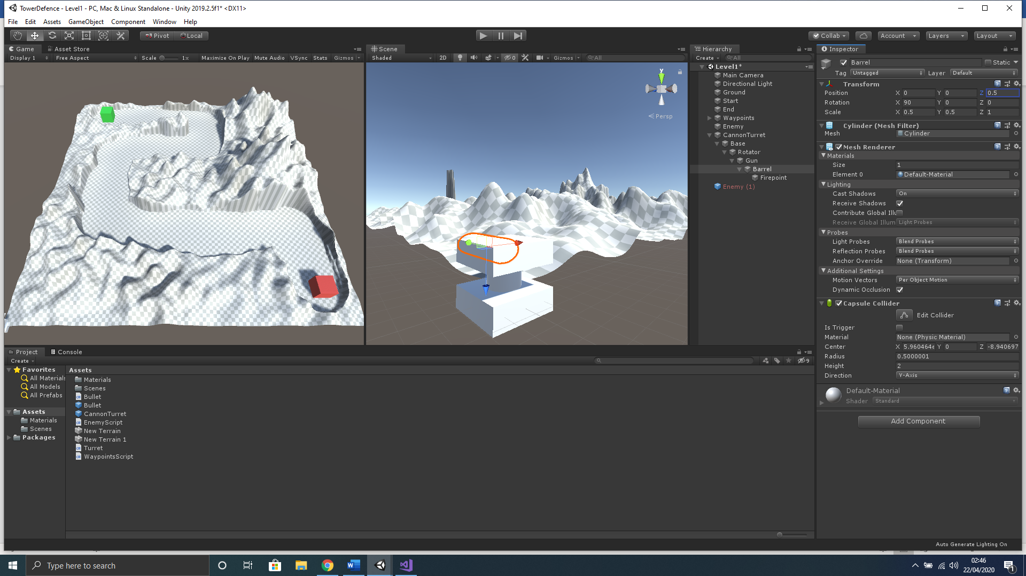
4. In the **Hierarchy, r**ight-click on the **Barrel** object and then select **Create Empty** from the context menu that appears.
5. Rename this cylinder in the **Inspector** to **FirePoint**.
6. The **Barrel** position should be adjusted in height by **1** on the **Y** position, so that it sits perfectly at the end of the barrel, where a bullet would appear from. Set the transform like below;
7. 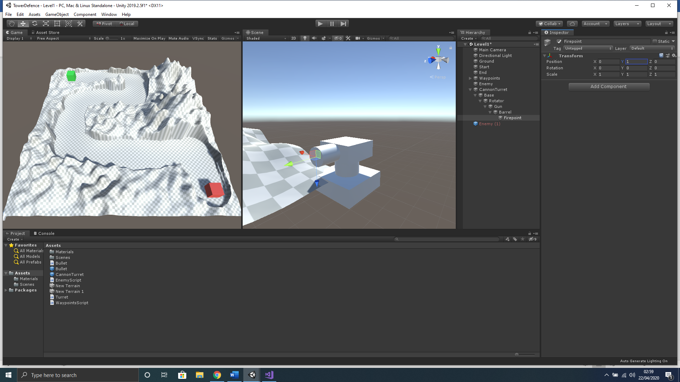

## Creating Turret Materials

You will notice it is quite hard to distinguish the **CannonTurret** from the **Ground** terrain object, therefore, we will create a material for the main gun colour, rotator and barrel object.

1. Now with nothing selected in **Hierarchy,** right-click in an empty space and select **Create>Material** from the context menu that appears.
2. Rename this **Material** to **Gun_Mat.**
3. With Gun_Mat still selected go to the Inspector and under Main Maps section select the colour picker tool next to Albedo component and change to a **Black** colour.
4. In the **Project** window make sure you are in **Assets>Materials** folder and left-click the **Gun_Mat** material once to select and use keyboard shortcut **CTRL+D** to duplicate the material twice.
5. Rename duplicated materials. One should be renamed **Rotator_Mat** and change the **Albedo** colour to **Bright Green**. The other should be **Barrel_Mat** with a bright **Albedo** such as **Red**. The bright colour is required make the Barrel object more visible, as the turret models will be rather small.

## Assigning Rotator/Barrel Materials

Now that we have created the materials for both the Start and End objects we must assign them to each corresponding object.

1. From the Project window left-click, hold and drag the **Gun _Mat** onto the **Gun** and **Base** object in the **Hierarchy** window.
2. From the Project window left-click, hold and drag the **Rotator _Mat** onto the **Rotator** object in the **Hierarchy** window.
3. Again, from the Project window left-click, hold and drag the **Barrel _Mat** onto the **Barrel** object in the **Hierarchy** window.

Here is an example of three different prototype turrets that have been created for another project;

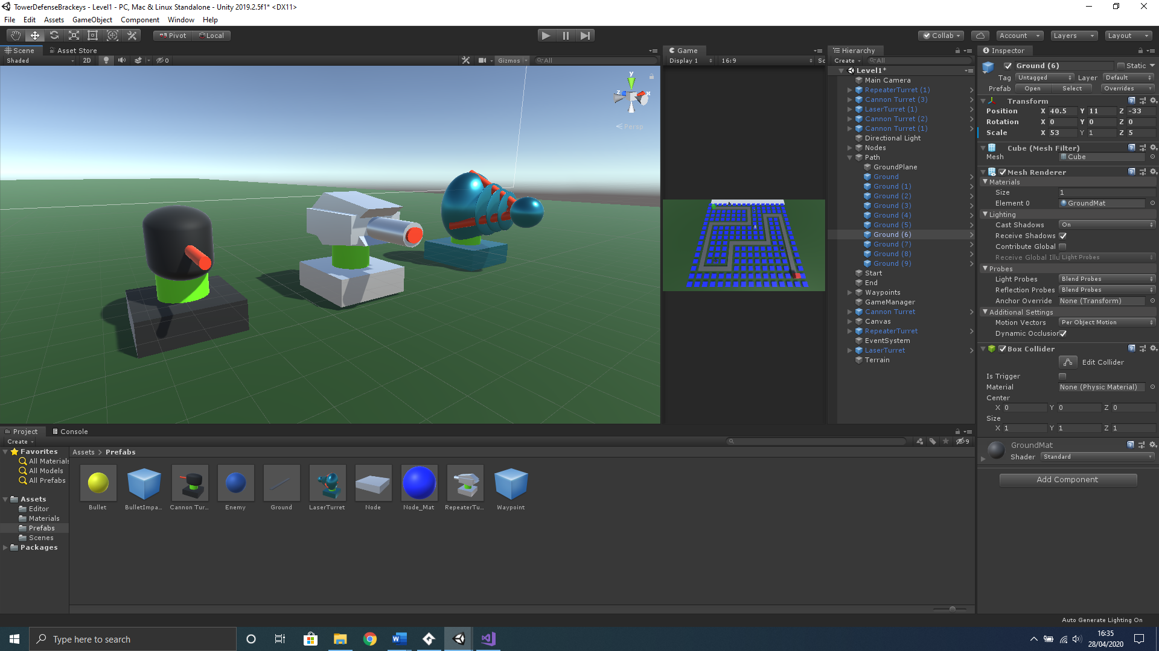

# Create a Game Manager

We will create a game manager object that will handle task within the game.

1. With nothing selected in the **Hierarchy**, use the keyboard shortcut **Ctrl+Shift+N** to create a new empty object.
2. Rename this object **GameManager**.
3. Now in the **Inspector, r**ight-click on the word **Transform** and then select **Reset.**

## Create a UI Countdown Display Text

We need to create a UI element to display our countdown text.

1. With nothing selected in the **Hierarchy** window, right-click in an empty space and select **UI>Text** from the context menu that appears.
2. Select the **Canvas** object in the **Hierarchy** and then hover your mouse over the **Scene** window and press the **F** on your keyboard to zoom straight to the selected object.
3. Click the **2D** button in the **Scene** window menu to edit the canvas. (You will notice the canvas is very big in comparrison to your actual level when editing. This is normal.)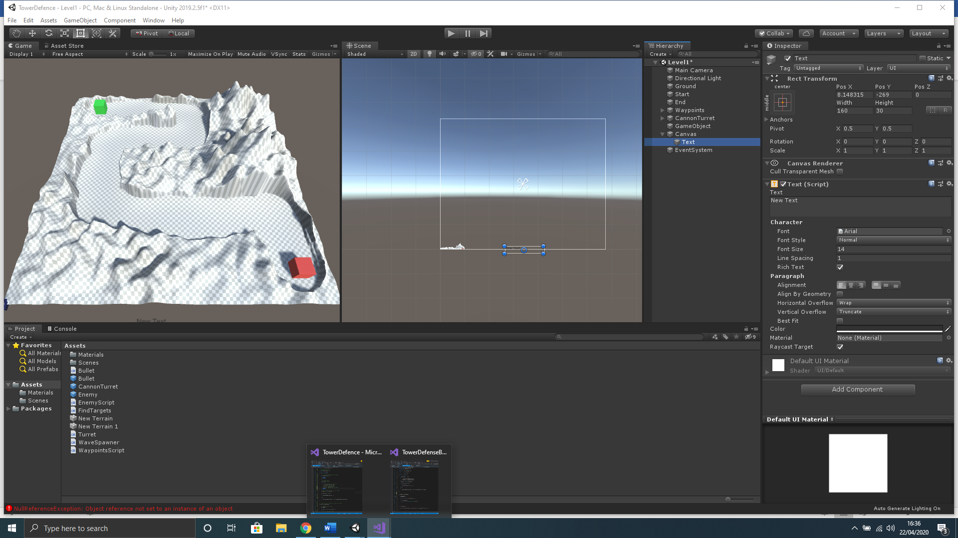
4. In the **Hierarchy** select the **Text** object atached to the **Canvas** and rename to **CountdownText**.
5. With the **CountdownText** object selected in the **Hierarchy** we anchor to the top of the screen but usinge the anchor function in the **Inspector**. Left click the achor tool.

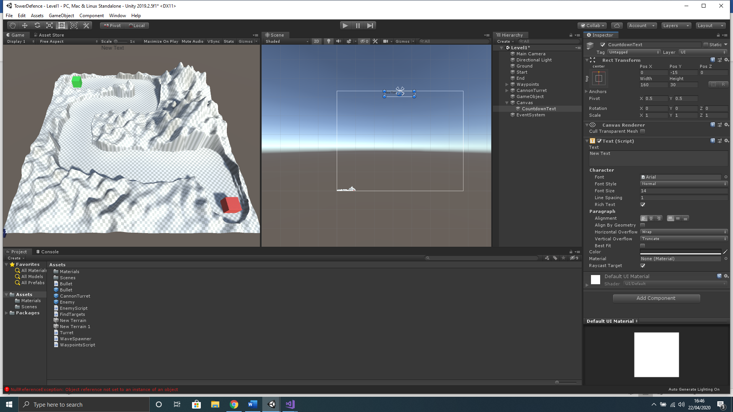

1. On your keyboard hold the Left-Alt key and the achor tool options will change where you want to left-click the top middle option.(this will anchor to the top centre of the screen) 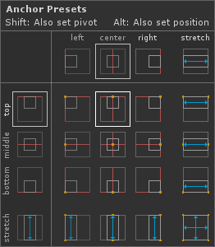
2. Now with **CountdownText** selected in the **Hierarchy**, press **F** key on your keyboard to zoom in on the **Scene** window.
3. Left-click on the **CountdownText** component and hold **left-shift** key on your keyboard to stick to centre axis, then slightly drag down a little to position.
4. Left-click on the little blue size tool on any corner of the **CountdownText** component and hold l**eft-alt** key on your keyboard to uniformly scale, then slightly drag out to increase the size of the component.

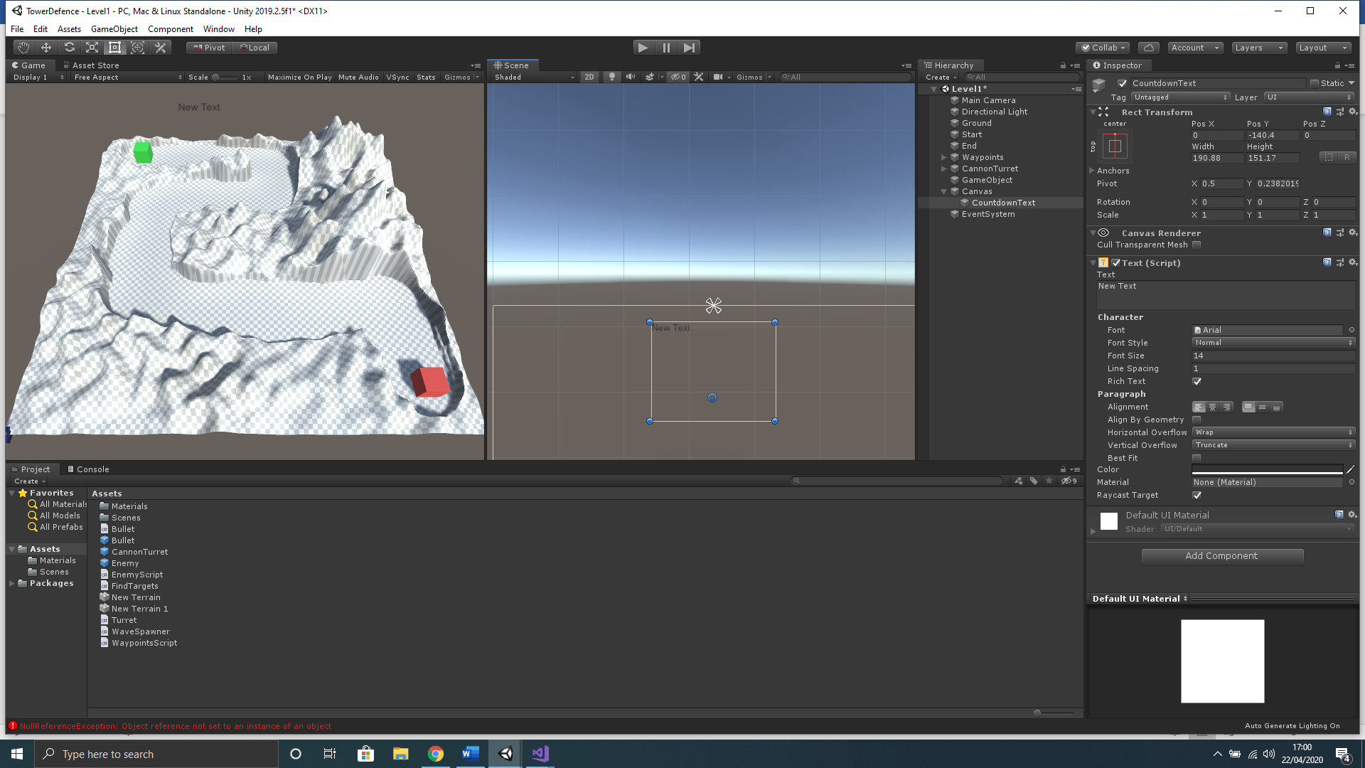

1. In the **Inspector** edit the **Text** component to format how the text displays change only the highlighted sections below; (this will make text more visible) 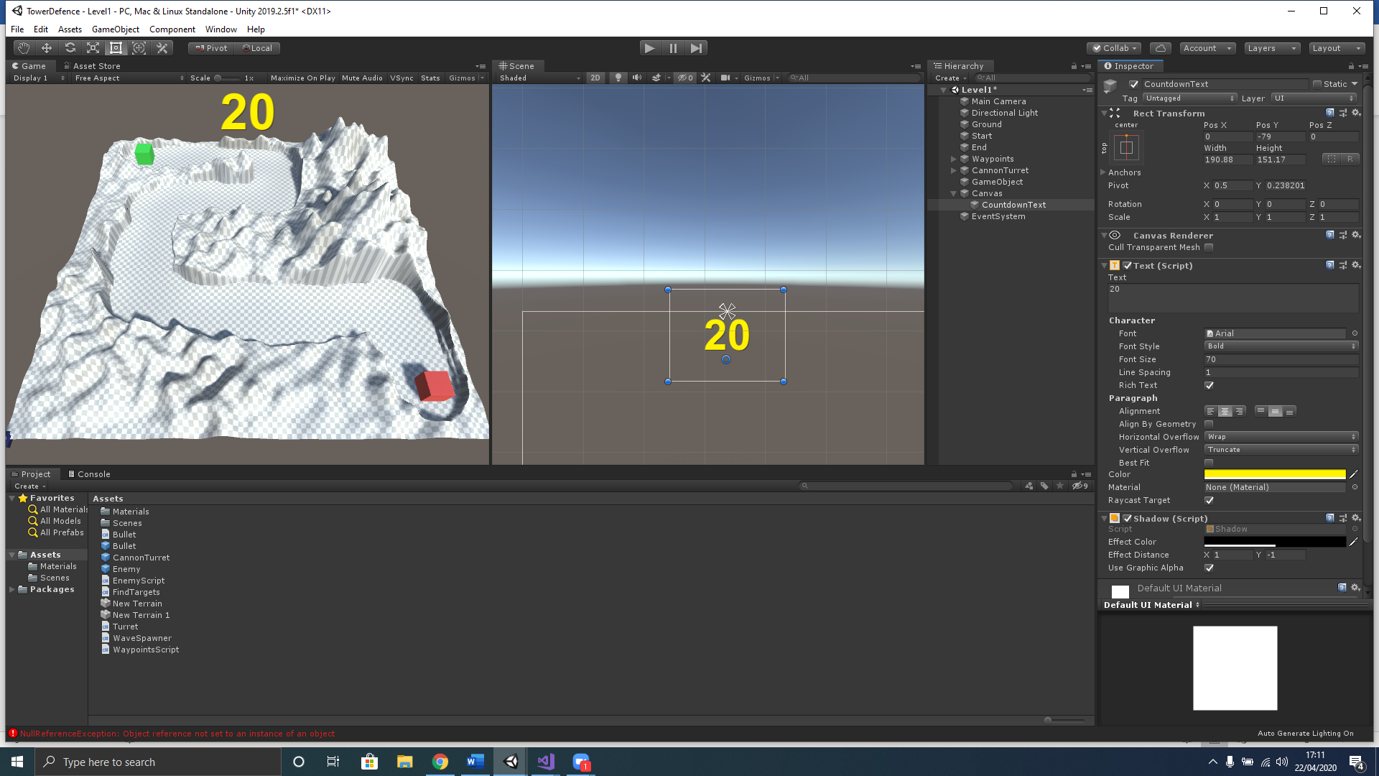

# Create a Wave Spawner

## Create the WaveSpawner Script

1. In the **Hierarchy** left click the **Enemy** object in the **Inspector** click the **Overrides** button, then click the **Apply All** buttonto add the changes we made in the script. Then we must delete it from the **Hierarchy** (scene) as we will be instantiating the prefab we created using the **WaveSpawner** script.
2. In the **Hierarchy** left click the **GameManager** object and, in the **Inspector**, left click the **Add Component** button.
3. In the search box that appears type the name **WaveSpawner,** then left click the **New Script** option below that is highlighted in blue.
4. Double check you have named the script properly, then left-click the **Create and Add** button.
5. Now in the **Project** window select the **Assets** folder and double left-click the **WaveSpawner** to open in Visual Studio.
6. Amend your **WaveSpawner** to contain the code below;
7. using UnityEngine;
8. using System.Collections;
9. using UnityEngine.UI;
10. public class WaveSpawner : MonoBehaviour
11. {
12. // count of enmies that are alive
13. public static int enemiesAlive = 0;
14. // reference to enemy prefab
15. public Transform enemyPrefab;
16. // refernce to spawn point
17. public Transform spawnPoint;
18. // time between waves
19. public float timeBetweenWaves = 5f;
20. // amount our countdown ticks from between waves initially set to time before 1st wave spawns
21. private float countdown = 2f;
22. public Text waveCountdownText;
23. // wave index identifier
24. private int waveIndex = 0;
25. private void Update()
26. {
27. // if no enemies left dont run the update
28. if (enemiesAlive > 0)
29. {
30. return;
31. }
33. // if timer reaches 0
34. if(countdown <= 0f)
35. {
36. // spawn a wave using a coroutine
37. StartCoroutine(SpawnWave());
38. // reset the countdown timer
39. countdown = timeBetweenWaves;
40. // wait til complete before contiuing
41. return;
42. }
43. // reduce countdown timer by 1 every second
44. countdown -= Time.deltaTime;
45. // if countdown less than 1 stop displaying the countdown
46. if (countdown <= 0.5f)
47. {
48. waveCountdownText.text = "";
49. }
50. else
51. {
52. waveCountdownText.text = Mathf.Round(countdown).ToString();
53. }
54. }
55. // spawn wave set on ienumerator to space out enemies
56. IEnumerator SpawnWave()
57. {
58. // increment the wave index
59. waveIndex++;
60. for (int i = 0; i < waveIndex; i++)
61. {
62. // call spawn enemy method
63. SpawnEnemy();
64. // wait set time before continuing
65. yield return new WaitForSeconds(0.5f);
66. }
68. }
69. void SpawnEnemy ()
70. {
71. // instantciate an enemy prefab
72. Instantiate(enemyPrefab, spawnPoint.position, spawnPoint.rotation);
73. // increment enemies alive count
74. enemiesAlive++;
75. }
76. }

## Hooking up Objects to the WaveSpawner Script

Now we have created the WaveSpawner script, we must hook up all the objects that we reference from the script inside the Unity editor.

1. In the **Hierarchy** left click the **GameManager** object to select.
2. Now in the **Inspector** window go to the **WaveSpawner** script and hook up the objects in the empty fields by left-clicking and dragging the required objects into the corresponding fields or select the object selection button and choose the appropriate object.
3. 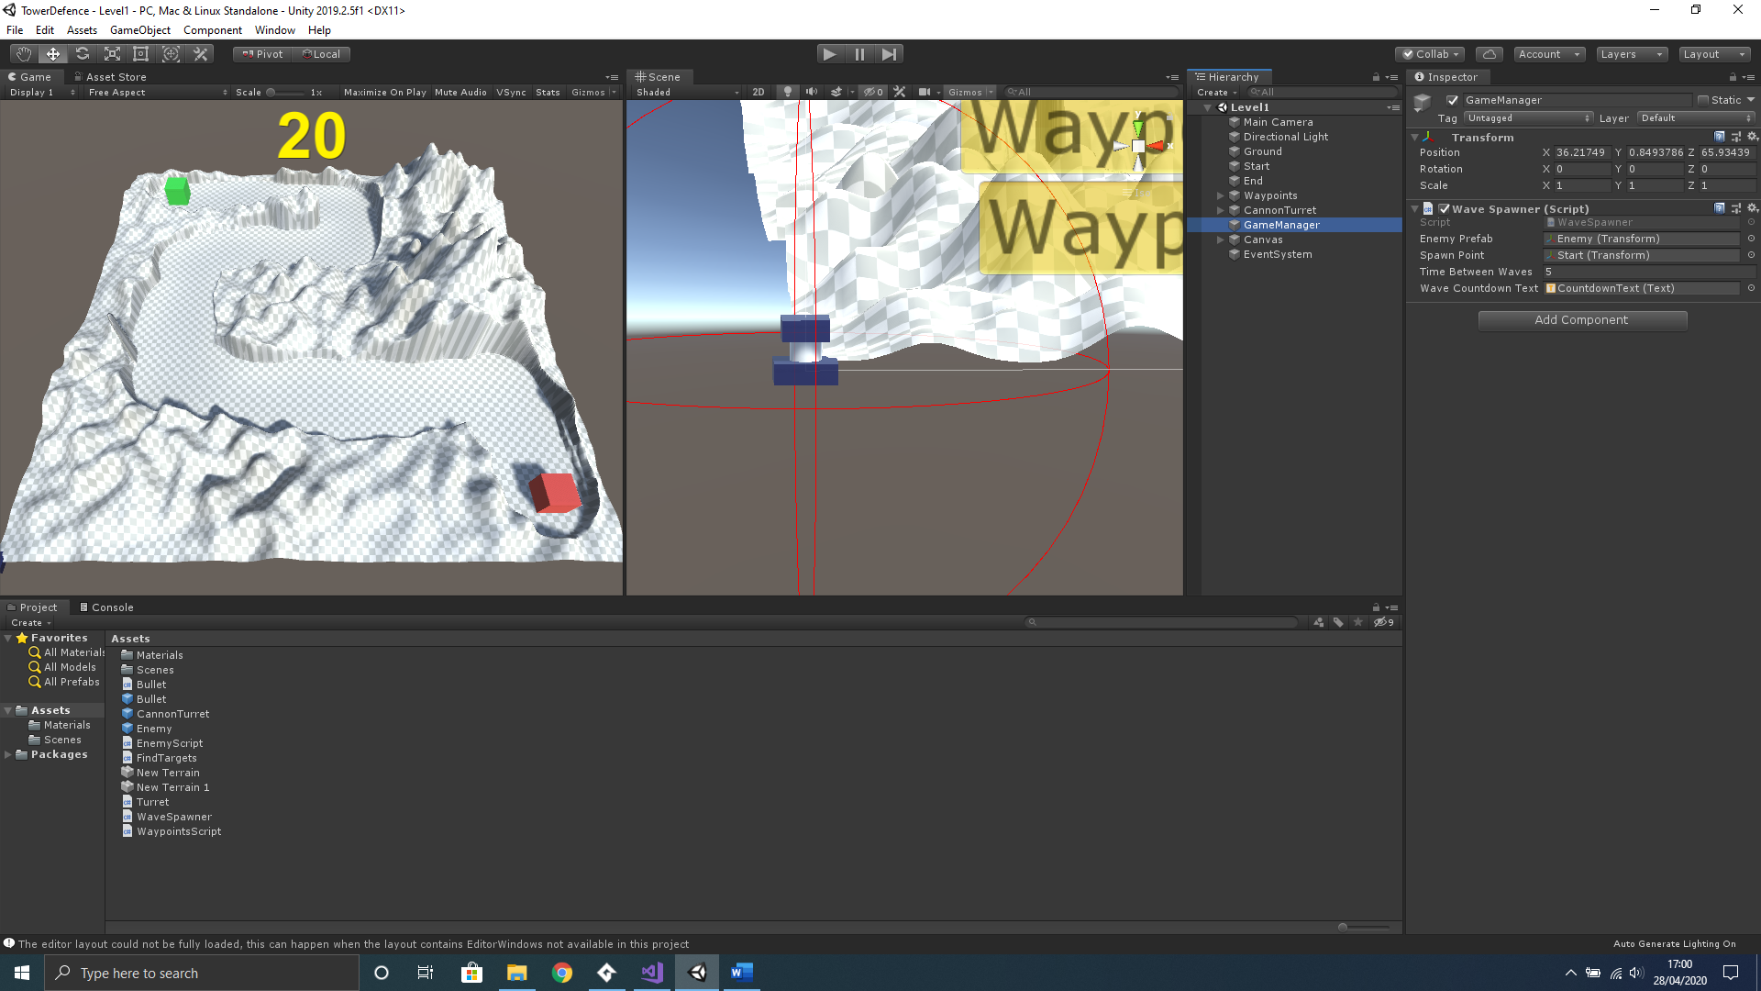
4. Now open your **EnemyScript** in Visual Studio and add the following lines after the code where you destroy the gameObject. This will reduce the number of enemies stored in the enemiesAlive variable, as the enemy has reached the End object without being killed.
5. // reduce the enemy count now that it has reached the end and destroyed
6. WaveSpawner.enemiesAlive--;
7. Now save all your scripts and return to Unity save and run and to test the project.

# Create a Turret Script

## Detecting Targets

We will now create a script to allow the turret to target and shoot the enemies. We first want to detect any targets within range of the turret. We will add a sphere collider to our turret to set the range of detection.

1. In the **Hierarchy** select the **CannonTurret** object and, in the Inspector, left click the **Add Component** button.
2. In the search box that appears type the name **Sphere Collider,** and select the **Sphere Collider** from the list.
3. As we are using this to trigger in the code we also must left-click the **Is Trigger** checkbox.(the checkbox must have a tick inside)
4. Set the **Radius** of the is **Sphere Collider** component to **15** to set detection range.
5. Again, in the **Hierarchy** select the **CannonTurret** object and, in the Inspector, left click the **Add Component** button.
6. In the search box that appears type the name **TurretScript,** then left click the **New Script** option below that is highlighted in blue.
7. Double check you have named the script properly, then left-click the **Create and Add** button.
8. Now in the **Project** window select the **Assets** folder and double left-click the **TurretScript** to open in Visual Studio.
9. Here we will add a variable to store the target and a function to the code to detect enemies within the radius of the sphere collider. We will also create a console log to show what enemies are detected. Leave the **Start** and **Update** functions for use later and amend your **TurretScript** to contain the code below;
10. using System.Collections;
11. using System.Collections.Generic;
12. using UnityEngine;
13. public class TurretScript : MonoBehaviour
14. {
15. // set variable to store target gameobject
16. private GameObject target;
17. // Start is called before the first frame update
18. void Start()
19. {
20. }
21. // Update is called once per frame
22. void Update()
23. {
25. }
26. void OnTriggerStay(Collider collidingObject)
27. {
28. // set the target to detected object
29. target = collidingObject.gameObject;
30. Debug.Log("Target = " + target.name);
31. }
32. }
33. Save the **TurretScript** and return to Unity.
34. Since we have used the **OnTriggerStay** Unity function we must add **Rigidbody** component to the enemy prefab as it will only detect objects that contain a rigidbody component. In the Project window double left click open your **EnemyPrefab.**
35. In the Inspector, left click the **Add Component** button.
36. In the search box that appears type the name **Rigidbody** and select the **Rigidbody** from the list.
37. As we are only using this to trigger in the code we also must left-click the **Use Gravity** checkbox to turn off. (the checkbox must NOT have a tick inside).
38. We also must left-click the **Is Kinematic** checkbox to turn on. (the checkbox must have a tick inside).
39. Let us test our turret script by positioning your 3D prototype **CannonTurret** at the beginning of the enemy path. Not too close, as we need to see the targeting in action, however, not too far away where the testing could take longer than necessary. Remember to move the object, first select the object in the Hierarchy, then press W key on the keyboard to show the movement **Translate** tool. Use the translate tools axis arrows to move on that axis. Alternatively, you can just type the position into the objects Tranform component in the Inspector.

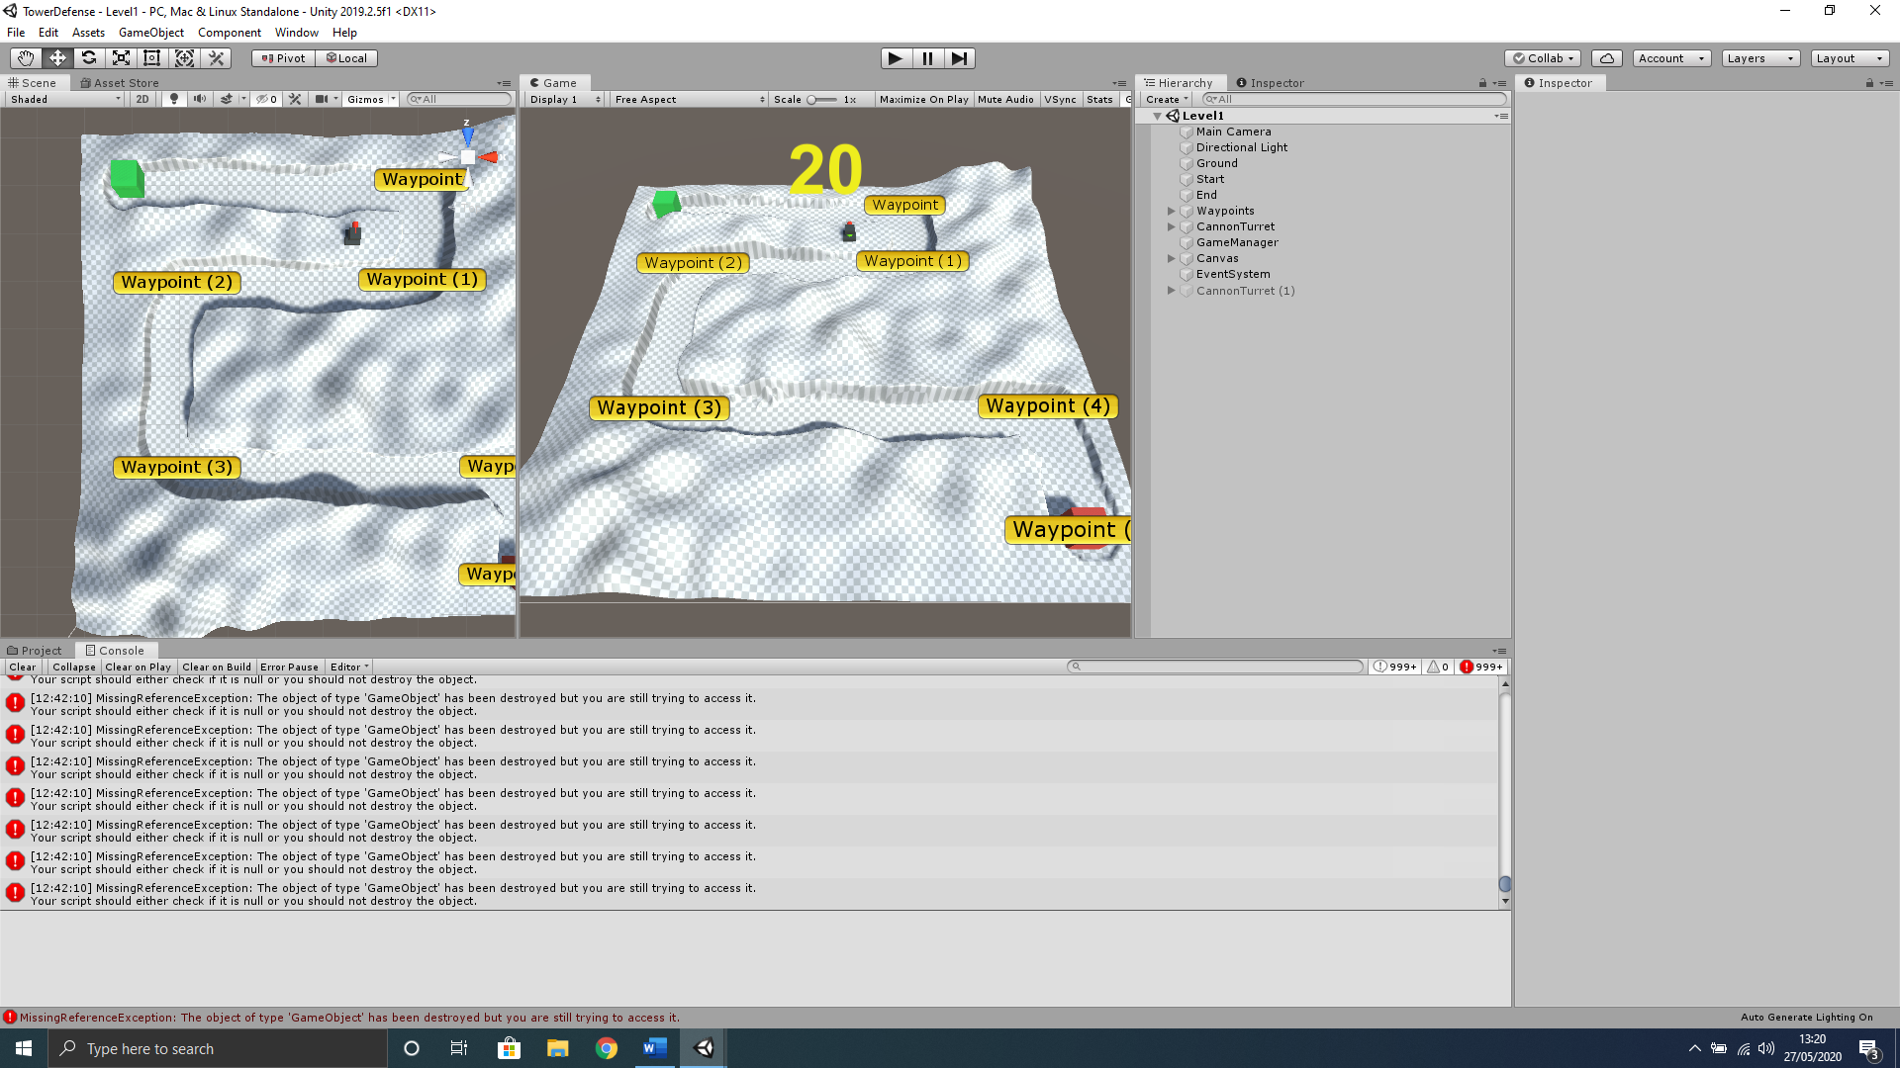

1. Save Your Project and run. You should now have console messages displayed when the enemy passes the turret.

## Follow Enemy Target

We will now have the gun face the enemy that has been detected. To do this we will reference the **Gun** object of the **CannonTurret** within the script and use the **Update** function in the **TurretScript** to set the gun object to face the target.

1. In the **Project** window select the **Assets** folder and double left-click the **TurretScript** to open in Visual Studio.
2. Set reference to **Gun** object. Amend your **TurretScript** to contain the code below;
3. // reference the turrets gun object
4. public GameObject gun;
5. Face direction of target location. Amend your **TurretScript** to contain the code below;
6. // point to target
7. gun.transform.LookAt(target.transform);
8. Save the **TurretScript** and return to Unity.
9. We must now select the **CannonTurret** in **Hierarchy** and connect the **Gun** object of this CannonTurret to the **Gun box** of the **TurretScript** in the **Inspector**.

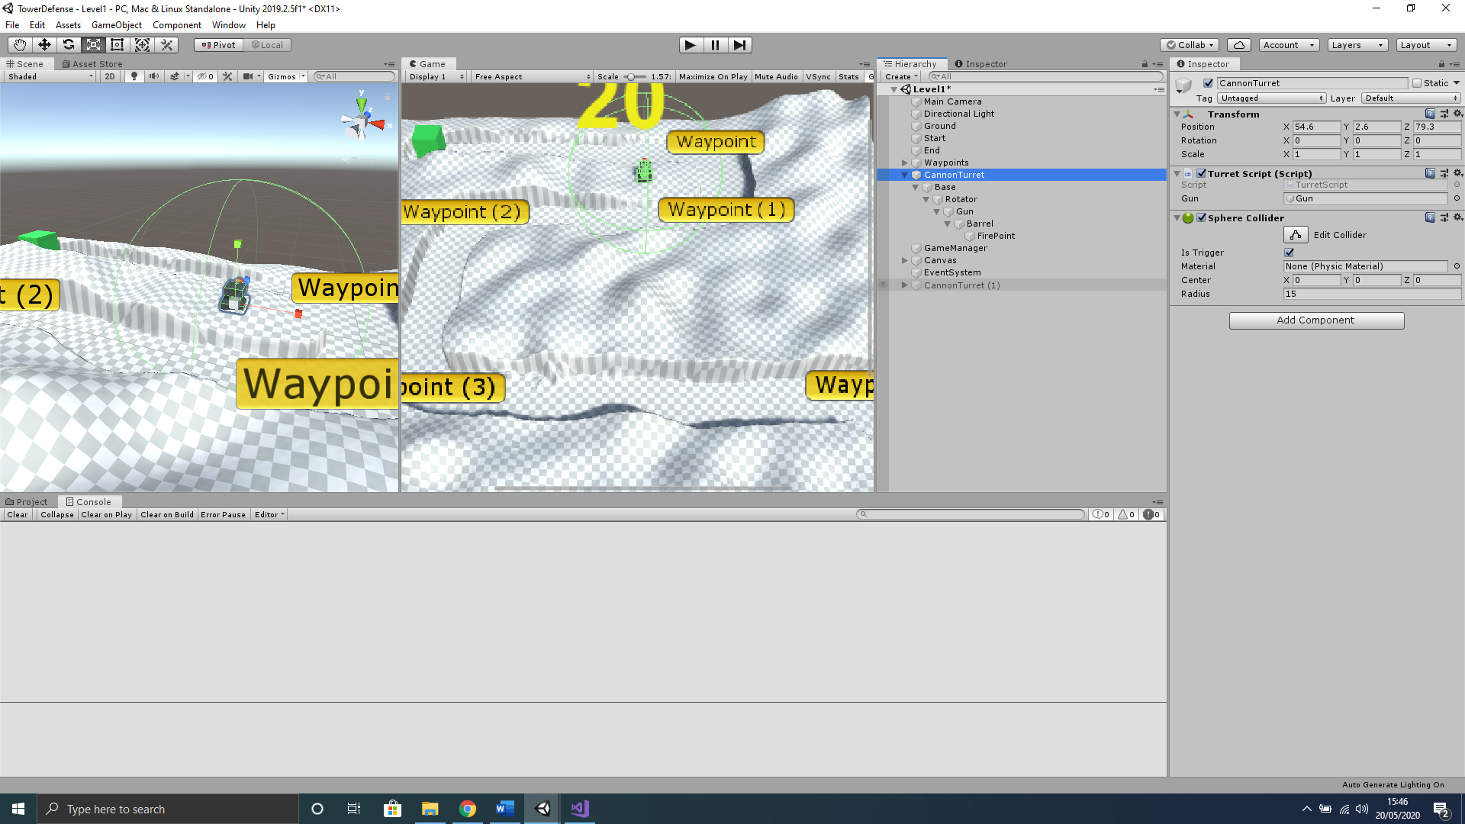

1. Save Your Project and run. Your turret should now face the enemy target when the enemy passes the turret.

At this stage when you run your project you will also notice that you get Reference Exception errors when there are no targets in range. This occurs as we are setting the Gun to face a target in the Update function and there have been no targets found. This can easily be fixed by returning out of the Update function if no target is found.

1. In the **Project** window select the **Assets** folder and double left-click the **TurretScript** to open in Visual Studio.
2. Only track available targets by adding this code to be first lines of code in the **Update** function, just before the point to target code. Amend your **TurretScript** to contain the code below;
3. // if no active target return
4. if (!target)
5. {
6. return;
7. }
9. Save the **TurretScript** and return to Unity and play to test.

You will notice that the error has now gone, however, you may also have noticed that the **CannonTurret** continues to track the enemy object even when it goes out of range. We can rectify this by adding a range variable to represent the turrets given range and a **distanceToTarget** variable to check if the enemy is within range, then set to look only at objects in range.

1. Set the turrets range. Amend your **TurretScript** to contain the code below;
2. // set range for turret
3. public float range = 15;
4. Only track objects in range. Amend the **Update** function of **TurretScript** to resemble below;
5. // Update is called once per frame
6. void Update()
7. {
8. // if no active target return
9. if (!target)
10. {
11. return;
12. }
13. else
14. {
15. // get distance to target
16. float distanceToTarget = Vector3.Distance(target.transform.position, transform.position);
17. // rotate to target only if in range
18. if (distanceToTarget <= range)
19. {
20. // point to target
21. gun.transform.LookAt(target.transform);
22. }
23. }
24. }
25. Save the **TurretScript** and return to Unity and play to test.

Your turret should now only track the enemy when they are within range. We will set the Radius of the **SphereCollider** attached to the **CannonTurret** equal to the range that we set, therefore we will only need to alter the range variable to change the range. We can do this by referencing the **SphereCollider** in the code and setting the **Radius** equal to the range variable.

1. Reference the **SphereCollider**. Amend the **TurretScript** to contain the code below;
2. // reference the SphereCollider component
3. public SphereCollider gunCollider;
4. Set the **SphereCollider** radius equal to the range on initialization. Amend the **TurretScript** to contain the code below;
5. // set the collider radius equal to the range
6. gunCollider.radius = range;
7. Set the **SphereCollider** radius equal to the range continuously in the **Update** function. Amend the **Update** function of the **TurretScript** to contain the highlighted code below;
8. // Update is called once per frame
9. void Update()
10. {
11. // set the collider radius equal to the range
12. gunCollider.radius = range;
13. // if no active target return
14. We can see the turrets range represented by the SphereCollider component, however, this is not the easiest to see, therefore, we will now add gizmos to show the turrets range within the scene more easily. Amend the **TurretScript** to contain the highlighted code below;
15. if (distanceToTarget <= range)
16. {
17. // point to target
18. gun.transform.LookAt(target.transform);
19. }
20. }
21. }
22. private void OnDrawGizmos()
23. {
24. // set gizmo colour
25. Gizmos.color = Color.red;
26. // set gizmo equal to range
27. Gizmos.DrawWireSphere(transform.position, range);
28. }
29. void OnTriggerStay(Collider collidingObject)
30. {
31. Save the **TurretScript** and return to Unity and play to test.

We now have a more functionally complete **TurretScript** that tracks enemies within range, however, you may have noticed that the turret snaps directly to the enemy, which looks rather unnatural. We can fix this so that the Turret has a fixed rotation speed, and use a lerp function so that we can turn the Gun object to face the target at a fixed speed.

1. We
2. In the **Hierarchy** select the **CannonTurret** object and **left-click hold and drag** it down to the **Prefabs** folder in the **Project** window to make a prefab